Dear [Recipient],
I am writing to formally decline the administration of the Flu Mist nasal spray for [child’s name]. My decision is based on several scientific and health considerations, particularly concerning the vaccine’s ingredients and its potential impact on health.
One of the primary concerns is the presence of Monosodium Glutamate (MSG) in the vaccine, which has been shown to affect the permeability of the blood-brain barrier. Research suggests that glutamate can increase this permeability by activating NMDA receptors, potentially allowing harmful substances to enter the central nervous system (Journal ofNeuroscience, 2016). Additionally, the shedding of live attenuated viruses from the vaccine recipient is another major concern. This can increase the risk of virus transmission, especially to vulnerable individuals.
There are numerous contraindications for children receiving this vaccine, including but not limited to:
- Asthma
- Allergies to eggs, egg proteins, or gelatine
- Immunocompromised conditions (or close contact with immunocompromised individuals)
- History of leukemia or lymphoma
- Use of corticosteroids (topical or inhaled)
- Adrenal insufficiency
- Blood disorders
- Use of acetylsalicylic acid

According to 4.3 of the manufacturers insert; - “Children and adolescents with clinical immunodeficiency due to conditions or immunosuppressive therapy such as: acute and chronic leukaemias; lymphoma; symptomatic HIV infection; cellular immune deficiencies; and high-dose corticosteroids should not receive the nasal spray. Fluenz Tetra is not contraindicated for use in individuals with asymptomatic HIV infection; or individuals who are receiving topical/inhaled corticosteroids or low-dose systemic corticosteroids or those receiving corticosteroids as replacement therapy, e.g. for adrenal insufficiency.”

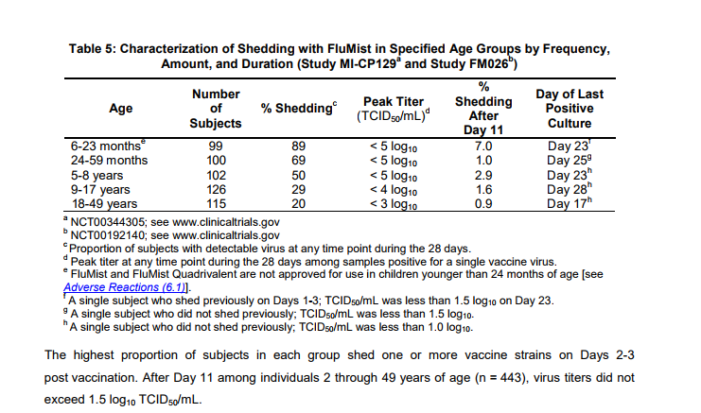
According to the vaccine insert, Fluenz Tetra is a live attenuated vaccine, which can result in shedding for several days, predominantly between Days 1-3 post-vaccination. Shedding studies, including those cited in the manufacturer’s documentation, indicate that vaccinated individuals can shed the virus for up to 28 days, with the highest proportion occurring within the first 3 days (Source).
"The highest proportion of subjects in each group shed one or more vaccine strains on Days 2-3 post vaccination. After Day 11 among individuals 2 through 49 years of age (n = 443), virus titers did not exceed 1.5 log10 TCID50/mL.”

"Virus shedding was evaluated for 21 days by culture of nasal swab specimens. Wild-type A (A/H3N2) influenza virus was documented to have circulated in the community and in the study population during the trial.”

“The FluenzTetra is a live vaccine which can shed for a matter of weeks afterwards but predominantly in days 1-3.”

“Fluenz Tetra contain live attenuated influenza viruses that must infect and replicate in cells lining the nasopharynx of the recipient to induce immunity. Vaccine viruses capable of infection and replication can be cultured from nasal secretions obtained from vaccine recipients (shedding) [see Pharmacodynamics (12.2)].”

It is crucial to note that this shedding can pose a significant risk to immunocompromised individuals. We have an immunocompromised family due to elderly relatives and those going through certain treatments. For this reason, I do not feel comfortable allowing [child’s name] to receive this vaccine or to be in close contact with those who have recently received it. To minimise potential exposure, I will be keeping [child’s name] home during the week following [insert specific dates] and I kindly request that this be marked as an authorised absence. We are happy to arrange for any schoolwork to be completed during this time, and we will supplement with our own educational activities.
Thank you for your understanding and cooperation on this matter.
Regards
[Your Name]

