Dear (XXX)

I do not give my permission for (XXX) to have this vaccine due to many reasons, but mainly due to the toxic ingredients including, but not limited to Monosodium Glutamate which opens up the blood brain barrier (https://www.jneurosci.org/content/36/49/12296#:~:text=Journal%20Club-,Glutamate%20Induces%20Blood%E2%80%93Brain%20Barrier%20Permeability%20through%20Activation%20of,%2DMethyl%2DD%2DAspartate%20Receptors&text=The%20blood%E2%80%93brain%20barrier%20(BBB,and%20cells%20into%20the%20CNS.) and the shedding that the vaccine unnaturally allows.

I struggle to believe that something that is marketed as ‘safe and effective’ can be dangerous for so many children.

Unsuitable for children if;

- They have asthma
- Have an allergy to eggs or egg protein or gelatin
- Are immune compromised
- Have family members who are immune compromised
- Have had leukaemia
- Have had lymphoma
- Are using topical steroids
- Are using inhaled corticosteroids
- Have adrenal insufficiency
- Have a blood disorder
- Are taking acetylsalicylic acid

According to the vaccine insert;
“The Fluent Tetra is a live vaccine which can shed for a matter of weeks afterwards but predominantly in days 1-3.”

“Fluenz Tetra contain live attenuated influenza viruses that must infect and replicate in cells lining the nasopharynx of the recipient to induce immunity. Vaccine viruses capable of infection and replication can be cultured from nasal secretions obtained from vaccine recipients (shedding) [see Pharmacodynamics (12.2)].”

12.2 - Shedding Studies Shedding of vaccine viruses within 28 days of vaccination with Fluent Tetra was evaluated in (1) multi-center study MI-CP129 which enrolled healthy individuals 6 through 59 months of age (N = 200); and (2) multicenter study FM026 which enrolled healthy individuals 5 through 49 years of age (N = 344). In each study, nasal secretions were obtained daily for the first 7 days and every other day through either Day 25 and on Day 28 or through Day 28. In study MI-CP129, individuals with a positive shedding sample at Day 25 or Day 28 were to have additional shedding samples collected every 7 days until culture negative on 2 consecutive samples.

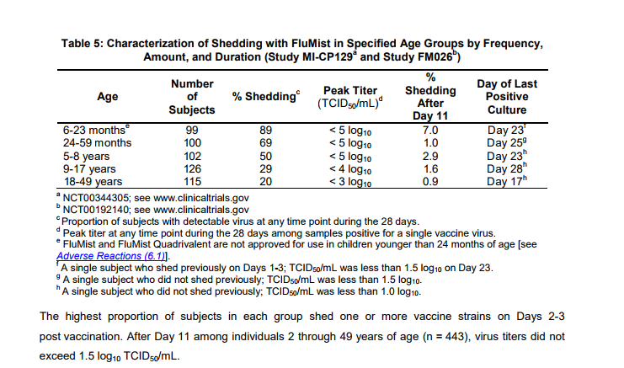
The highest proportion of subjects in each group shed one or more vaccine strains on Days 2-3 post vaccination. After Day 11 among individuals 2 through 49 years of age (n = 443), virus titers did not exceed 1.5 log10 TCID50/mL.

"Virus shedding was evaluated for 21 days by culture of nasal swab specimens. Wild-type A (A/H3N2) influenza virus was documented to have circulated in the community and in the study population during the trial.”

According to 4.3 of the manufacturers insert; - “Children and adolescents with clinical immunodeficiency due to conditions or immunosuppressive therapy such as: acute and chronic leukaemias; lymphoma; symptomatic HIV infection; cellular immune deficiencies; and high-dose corticosteroids. Fluenz Tetra is not contraindicated for use in individuals with asymptomatic HIV infection; or individuals who are receiving topical/inhaled corticosteroids or low-dose systemic corticosteroids or those receiving corticosteroids as replacement therapy, e.g. for adrenal insufficiency.”

As you can see, it is possible for those vaccinated with the spray to spread flu, particularly amongst immune compromised people. Quoted from source: https://www.medicines.org.uk/emc/product/3296/smpc/print#CONTRAINDICATIONS

As you can see, there is sufficient evidence to support the fact that the vaccine does shed quite predominantly. Due to this, I do not want (XXX) to be in direct contact with anyone receiving the flu mist for the rest of that week as it could put us all at risk; so we will be keeping (XXX) home on (XXXXXXX) dates.

I would appreciate it if this could be noted as authorised absence due to nature of having to keep them off. If (XXX) teachers would like to send home any work for them to do, we are more than happy to oblige, but we shall be doing our own home educating on those days.

Regards

